***HTML CSS Javascript Website Tutorial***

***Responsive Beginner JS Project with Smooth Scroll***

***CREATING NAVIGATION BAR***

Start by creating a file in your folder. Create index.html, styles.css and app.js.

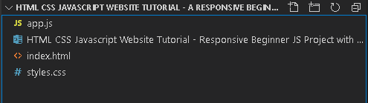

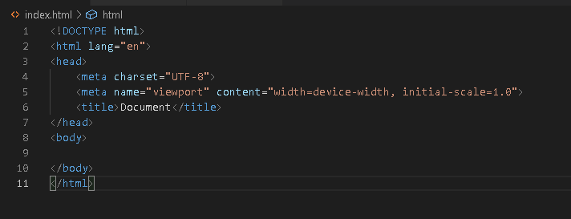Go to index.html, on short cut press shift + 1 = ! to bring a huge block of html.

Let’s link to style sheets so,

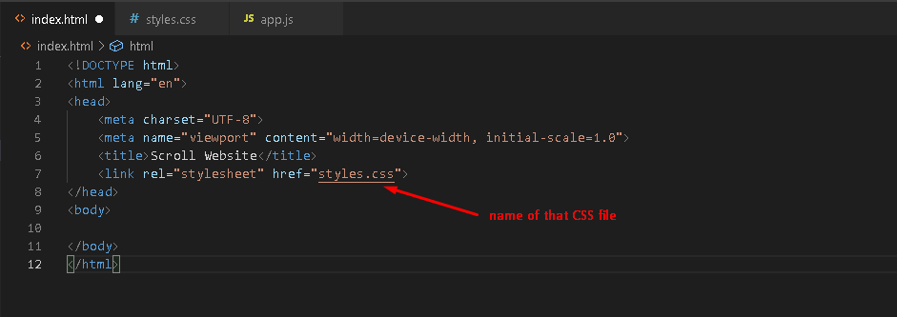

Then let’s go to our body section and go ahead and start creating actual website design. So, first thing first, I’m going to create navigation bar. So,

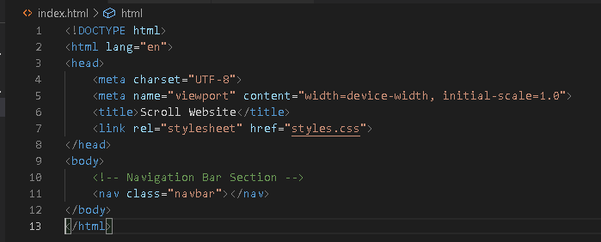

Just go ahead and type nav dot and name of your class, you can see a suggestion. Note that to add a comment just press ctrl + slash. Feel free to name your class.

Now, let’s create navbar container, so, type dot navbar double underscore then container,

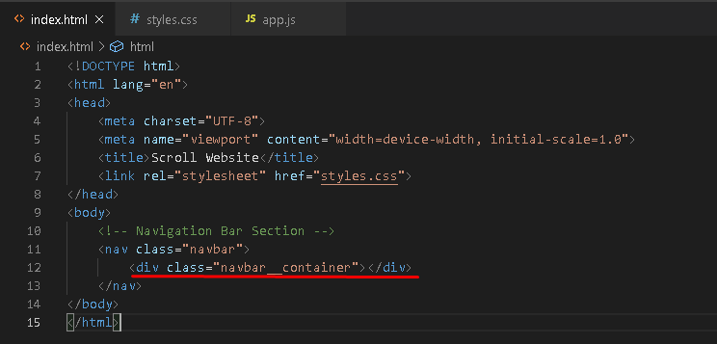

Its automatically create div. Now let’s create <a> text. So, to add <a> text type “a#nameofyourId”.

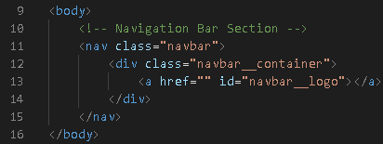

Then for the href, since we’re using html css this is the easiest way to do the little scroll effect.

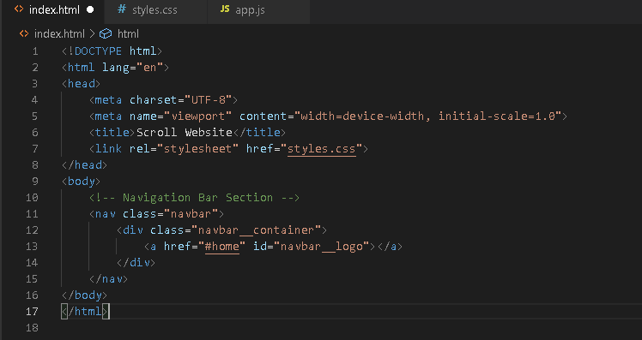

Then inside this <a> here, let’s say color, by the way, on extension search for live server then install it.

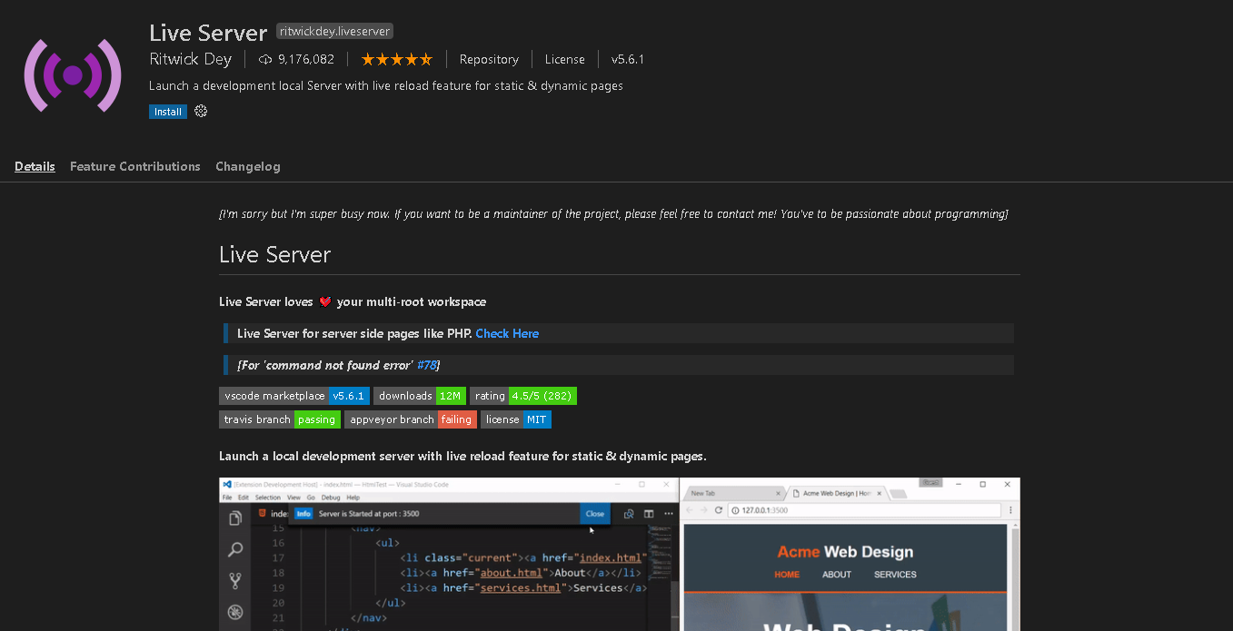

This is what it can do is when I right click

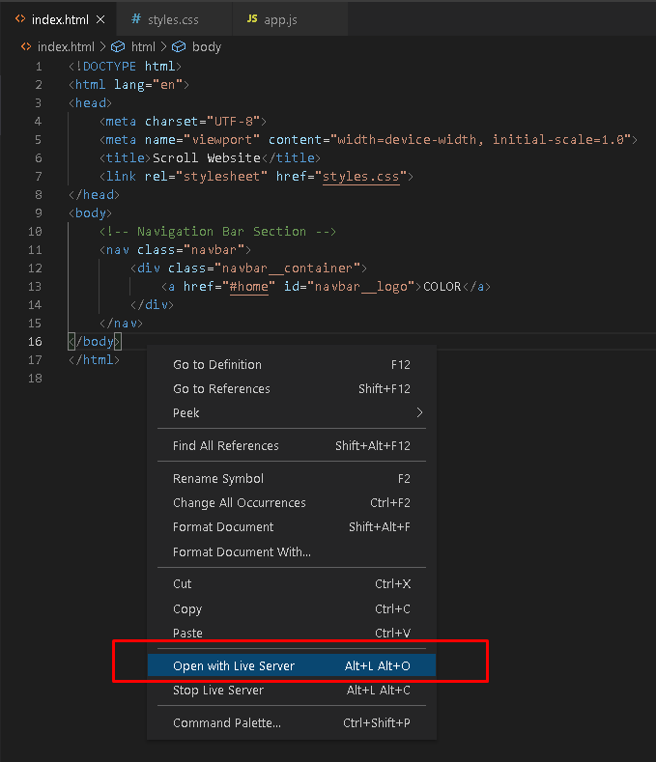

And also, it automatically updates if any codes we’re change. And now underneath this </a> (a closing remark for tags which will be learn on basic html) I will now create the actual navbar.

It will be a div so, dot navbar underscore 2 times toggle, it also has an id so add #.

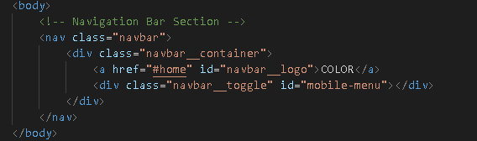

Under this dev here, we add span, so type, “span.bar” leave it empty then add 3 of this so the shortcut is shift + alt + down-arrow.

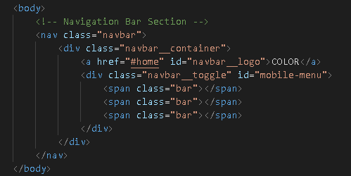

Under this div, now I will create the actual nav menu, using unordered list. So, type “ul dot navbar” always remember that dot is for clash and number sign is for id.

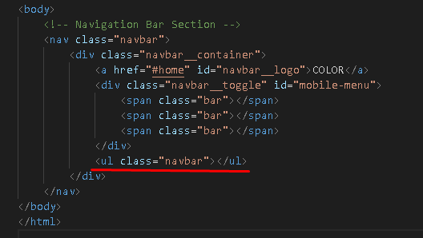

Under this <ul> is will be the place for the list of items so type “li dot navbar double underscore item”

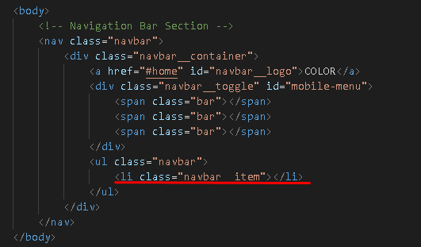

Inside this <li> I will insert <a> with class name of navbar double underscore links and an id of home-page.

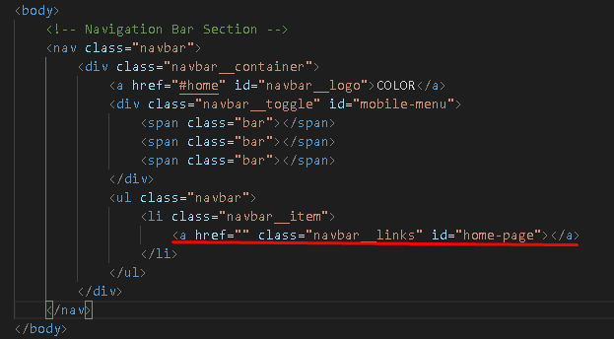

And we put href with #home,



And inside this <a> let’s insert this home,



This is the view from the page,

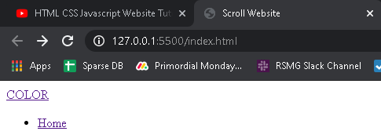

We just need to copy this <li>,

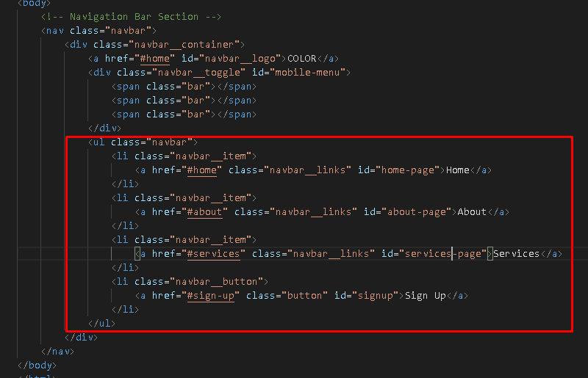

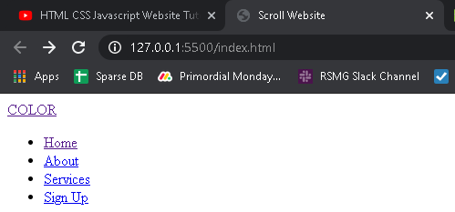The view from the page,

***Styling our Navigation Bar***

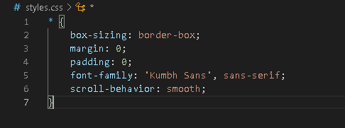Go to style.css, let’s start by adding this,

You’ve notice that all move to corner because we remove paddings and everything. So, start by dot navbar,

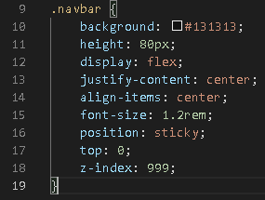

Background is the color and hashtag are the hex number of the color.

Height is very understandable.

Display is the main display of this characters and flex is for flexible in any size of the window.

Justify-content just like MS Word, same with align-items.

Font-size is the size of fonts with the unit rem, default value of rem is n x 16.

Position is property specifies the type of positioning method used for an element and sticky is positioned based on the user’s scroll position.

Top value is zero so it’s the very top. Z-index make this thing above everything, think of it like a 3D type where it’s like sticking out then the value is ridiculous, no matter what I do with my site it’s above everything.

Then the navbar container

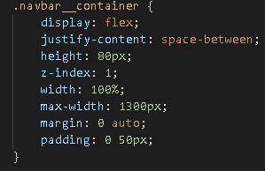

Justify-context space-between is going to add some spacing.

For margin sequence is top right bottom left. Top and bottom are just the same so its zero left and right are the same so we just say auto.

Next will be the navbar logo.

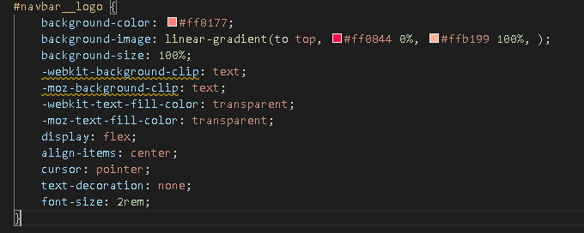

-webkit-text-fill-color this (for chrome and safari3) property specifies the fill color of characters of the text.

If this property is not specified, the value of the [color](https://www.w3docs.com/learn-css/color.html) property is used. Alternative for this for firefox browser is moz-text-fill-color.

The background-clip property defines how far the background (color or image) should extend within an element.

The cursor property specifies the mouse cursor to be displayed when pointing over an element.

The text-decoration property specifies the decoration added to text, and is a shorthand property for:

* text-decoration-line (required)
* text-decoration-color
* text-decoration-style

For .navbar__menu

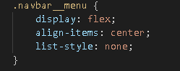

For .navbar__item



For .navbar__links

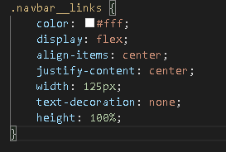

For .navbar__button

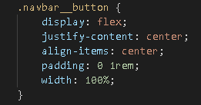

For .button

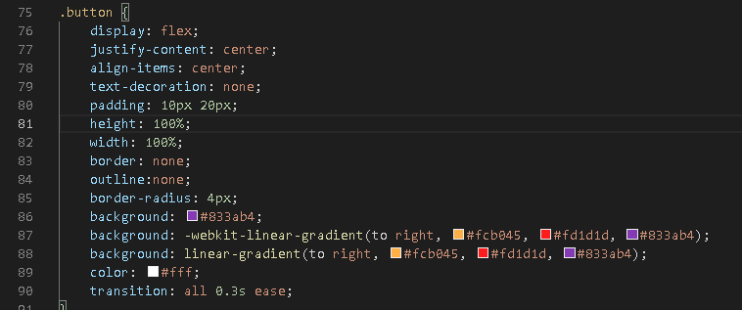

For .navbar__links:hover

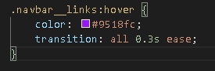

For @media screen and (max-width: 960px), The @media rule is used in media queries to apply different styles for different media types/devices.

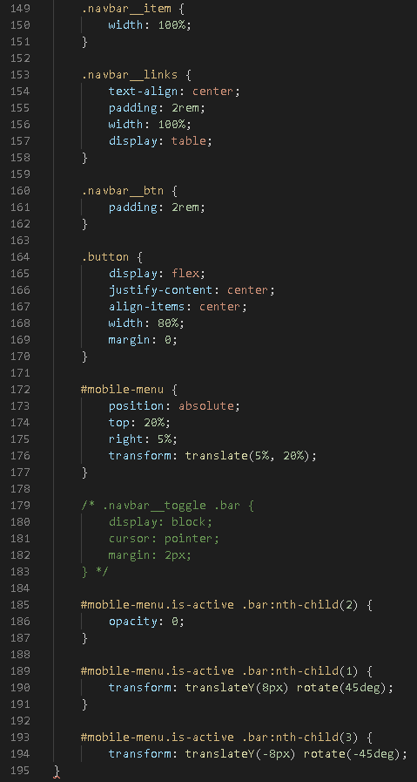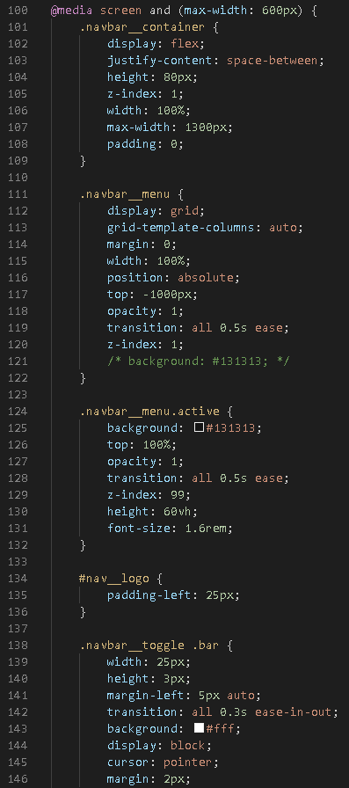Well, you don’t need to memories all of this css property. Take a look on this line of code inside media.

***Toggle Menu with JavaScript***

Go to app.js file, let’s target the first thing.